LEARNING MANAGEMENT SOFTWARE

Team MAET

**Team Members:** Emmanuel Ogunkoya, Jonathan Thomas, Savorn Sam, Christopher Kania, Aaron Raoofi

CS 3321: Introduction to Software Engineering

Department of Computer Science and Engineering Technology

University of Houston – Downtown

Spring 2019

Table of Contents

CHAPTER 1: overview 1

**SECTION 1.1: PROJECT SUMMARY** 1

SECTION 1.1.1: PURPOSE, SCOPE, AND OBJECTIVES 1

Section 1.1.1a: Purpose 1

Section 1.1.1b: Scope 1

SECTION 1.1.1C: Objectives 1

SECTION 1.1.2: ASSUMPTION AND CONSTRAINTS 2

Section 1.1.3: Project deliverables 2

Section 1.1.4: Schedule and Budget Summary 2

Section: 1.2: Eveolution of the Project management Plan 2

CHAPTER 2: REFERENCE MATERIALS 3

BIBLIOGRAPHY 3

Chapter 3: defnition and acronyms 4

Section 4.1: External Interfaces 5

Section 4.2: Internal Structure 5

Section 4.3: Roles and Responsibilities 5

chapter 5: Managerial process Plans 6

Section 5.1: Start-Up Plan 6

Section 5.1.1: Estimation Plan 6

Section 5.1.2: Staffing Plan 6

SEction 5.1.3: Resource Acquisisiton Plan 6

Section 5.1.4: Project Staff Training Plan 6

Section 5.2 Work Plan 6

Section 5.2.1: Work Activities 6

Section 5.2.2: work activities 6

Section 5.2.3: Budget Control Plan 6

Section 5.2.4: Quality Control Plan 6

SEction 5.3 Control Plan 6

Section 5.3.1: Requirements Control Plan 6

Section 5.3.2: Schedule Control Plan 7

Section 5.3.3: Budget Control Plan 7

Section 5.3.4: Quality Control Plan 7

Section 5.3.5: Reporting plan 7

Section 5.3.6: Metrics Collection Plan 7

Section 5.4: Risk management plan 7

Section 5.5 project Close-Out Plan 7

chapter 6: technical process plan 8

Section 6.1: Process model 8

Section 6.2: Methods, Tools & Techniques 8

Section 6.3: Infrastructure Plan 8

Section 6.4: Product Acceptance Plan 8

7: supporting process plan 9

Section 7.1: Configuration management Plan 9

Section 7.2: Testing Plan 9

Section 7.3: Documentation Plan 9

Section 7.4: Quality Assurance Plan 9

Section 7.5: Reviews and Audits Plan 9

Section 7.6: Problem Resolution Plan 9

Section 7.7: Subcontractor management Plan 9

Section 7.8: Process Improvement PlaN 9

8: additional Plan 10

Appendix 11

appendix a: Entities 12

appendix b: Classes 13

appendix c: Login Page 14

appendix D: Major User ViewS 15

appendix e: Use Cases 17

appendix F: Diagrams 18

UML Diagram 18

E/R Diagram 18

Detail Class Diagram 18

appendix g: Meeting Minutes 19

# CHAPTER 1: overview

**SECTION 1.1: PROJECT SUMMARY**

As students, we are taught the theoretical and conceptual ideas and tools that we may apply in private and public sectors after graduation. We are given the opportunity to apply class room learning to a hand-on project. We (Emmanuel Ogunkoya, Jonathan Thomas, Savorn Sam, Christopher Kania and Aaron Raoofi) will take concepts taught in class, along with our cumulative working knowledge in various programming languages, as real-world experiences and apply them in creating a functioning “Learning Management System” which will display various student information as it pertains to a university institute.

## SECTION 1.1.1: PURPOSE, SCOPE, AND OBJECTIVES

### Section 1.1.1a: Purpose

The Learning Management System will provide information about a student(s) academic information, such as, student’s name, student’s ID, registered courses in the current semester, each exam’s scores in one course, GPA calculation in the current semester.

### Section 1.1.1b: Scope

The UML is a brief example of the overall lengthier project. For now, the information provides will be for demonstration purposes. Information provided in the database (course name, id, student name, student ID or any other information) will not be for any real person(s) located at the University of Houston – Downtown or any known person.

### SECTION 1.1.1C: Objectives

* Team will analyze the requirements of the semester project.
* Review, analyze and develop life cycle model
* Review, analyze and develop team model
* Assign team member responsibilities
* develop and apply UML method
* create UML diagram
* create and maintain data records
* create Graphical User Interface (GUI)
* The program will have to access modes (student view and administrator view)
* Software will have a login page with stored login name and password.
* Software program will calculate GPA based on provided exam scores and/or quiz scores.
* The software program will store basic information (student name, student ID, registered courses, exam scores)
* The Program will display basic information, listed above, as well as GPA

## SECTION 1.1.2: ASSUMPTION AND CONSTRAINTS

Due to the time frame of this project, student knowledge, the Learning Management System will not be completely functional, rather, it will have partial functionality. The information used within the system (student information, administrator information as well as class name and course ID) are completely fictional.

## Section 1.1.3: Project deliverables

The following items will be submitted:

* Final Project Report
  + The report will include information such as the number of members in our team, team member’s names, type of team model, UML diagrams, SPMP
* Source Code
* Data storage files, and
* any other documentation required per the project assignment

## Section 1.1.4: Schedule and Budget Summary

The final project due date is April 28th, 2019 during usual class time. Budget is not applicable to this project.

## Section: 1.2: Eveolution of the Project management Plan

During the course of this project should any changes, re-evaluation, or revision to this SPMP will be done under group review. Changes shall be done by any team members.

# CHAPTER 2: REFERENCE MATERIALS

# **BIBLIOGRAPHY**

*GitHub*. (2019). Retrieved from GitHub: https://github.com/

Schach, S. R. (2007). *Object-Oriented and Classical Software Engineering, 8th Edition.* New York: The McGraw-Hill Companies, Inc.

# Chapter 3: defnition and acronyms

**DTA**: Democratic Team Approach

**LMS**: Learning Management System

**SPMP**: Software Project Management Plan

**UML**: Unified Modeling Language

chapter 4: project organization

## Section 4.1: External Interfaces

As the team is small, any interactions will be conducted either in group meetings between the team and the University of Houston- Downtown or with the team lead.

## Section 4.2: Internal Structure

Currently, our team will be using a combination Democratic Team Approach (DTA) as well as the Classical Chief Programmer Team Approach. Each member has had specific knowledge and skills involving different aspects of the project. Aaron Roofi has taken a defacto leadership role, due to his extensive knowledge and leadership skills. As this is an early stage, each member has voluntarily expressed his or her interest and strengths as well as volunteered for various aspects in this project.

## Section 4.3: Roles and Responsibilities

* Christopher, Kania: Database Design and Database Engineer, Programmer, Artifact Contributor
  + Student at the Computers Science major at the University of Houston – Downtown
* Ogunkoya, Emmanuel: UML developer and Artifact-Contributer, Progammer
  + Student at the Computers Science major at the University of Houston – Downtown
* Raoofi, Aaron: Team Lead, Artifact-Contributor, Programmer
  + Student at the Computers Science major at the University of Houston – Downtown
* Savorn Sam: Programmer for Login page, GUI development
  + Student at the Computers Science major at the University of Houston – Downtown
* Jonathan Thomas: Artifact-Lead and Contributor
  + Student at the Computers Science major at the University of Houston – Downtown

# chapter 5: Managerial process Plans

## Section 5.1: Start-Up Plan

### Section 5.1.1: Estimation Plan

The deadline for this project is April 28, 2019. Work will be conducted after class and anytime required as requested by the team. No budget is required at this time.

### Section 5.1.2: Staffing Plan

Staff will consist of the five team members listed in Section 4.3 above.

### SEction 5.1.3: Resource Acquisisiton Plan

The team will use their own personal computers and software. Any software resources needed will either be provided through the school or “free to use” via the Internet.

### Section 5.1.4: Project Staff Training Plan

Any training necessary to complete this project will either be provided through academic resources, peer-to-peer training, free-to-use resources, or through the Internet.

## Section 5.2 Work Plan

### Section 5.2.1: Work Activities

Each team member has been assigned a task based on their strengths or knowledge about a particular part of the LMS. Tasks assigned are stated in Section 4.3 above. Each team member is also required to submit their documentation regarding their particular task assigned. Each team member will review their own work and at weekly meetings during class time, their work product will be reviewed by others within the team.

### Section 5.2.2: work activities

Members of the team are to work in their free time outside of regular work or academic schedule. After class, meetings to discuss issues, solutions, project requirements or any other topic will occur.

### Section 5.2.3: Budget Control Plan

As there is no budget needed for the project, this section is not applicable.

### Section 5.2.4: Quality Control Plan

Each team member is in charge of their own quality control. At any time, during the project, any team member can review others work.

## SEction 5.3 Control Plan

### Section 5.3.1: Requirements Control Plan

The requirements for this project have been assigned at the very beginning of this project. However, should any requirements changes occur, they should occur through written means. Any documentation will be updated immediately to reflect the changes and will be noted with the date the requirement changed as well as the date any Artifact was updated as well.

### Section 5.3.2: Schedule Control Plan

Progress will be measured by the Artifacts produced and well as documentation stored on the GitHub website.

### Section 5.3.3: Budget Control Plan

Currently, there is no need for a budget as all equipment, software, team member time are all at no cost.

### Section 5.3.4: Quality Control Plan

Each team member is required to check their work for correctness of their code and documentation. However, final review will be done at weekly, scheduled meetings.

### Section 5.3.5: Reporting plan

Any requirement changes will be done through the instructor or documented on the “Black Board” system. Any requirement changes will then go to Section 5.3.1 for any adjustments. Scheduling issues and adjustments will be addressed through weekly meetings after class. Budget is not applicable to the project.

### Section 5.3.6: Metrics Collection Plan

Metrics collection is not applicable to the project currently.

## Section 5.4: Risk management plan

The current issue with the project is if a team member is unable to complete his or her part of the project. Should there be a team member that is unable to compete their project due to any unforeseen circumstance or withdrawing from the project then at the weekly meeting, other team members will be assigned the incomplete portion of the project. The team member that is leaving is required to turn-in any code, documents, artifact that pertain to the project at the GitHub website.

## Section 5.5 project Close-Out Plan

At the close of the project all team members will be required to be present at the presentation of the project and to discuss their portions of the project.

# chapter 6: technical process plan

## Section 6.1: Process model

The process selected for the project was the Waterfall Life-Cycle Model (WLCM). Due to the short time frame and the simplicity of the project this was the, by consensus, the best solution. The documentation provided at the beginning of the project outlined all requirements and deadlines needed.

## Section 6.2: Methods, Tools & Techniques

[TBD]

## Section 6.3: Infrastructure Plan

[TBD]

## Section 6.4: Product Acceptance Plan

The final product will be judged based on requirements set out in the project outline as well as based on presentation given on the delivery date.

# 7: supporting process plan

## Section 7.1: Configuration management Plan

## Section 7.2: Testing Plan

All software is tested when completed.

## Section 7.3: Documentation Plan

## Section 7.4: Quality Assurance Plan

## Section 7.5: Reviews and Audits Plan

No reviews or audits are currently required for this project.

## Section 7.6: Problem Resolution Plan

## Section 7.7: Subcontractor management Plan

No Subcontractors were used during the project and are not applicable.

## Section 7.8: Process Improvement PlaN

# 8: additional Plan

None applicable at this time.

# Appendix

## appendix a: Entities

|  |  |  |
| --- | --- | --- |
| **Entity** | **Boundary** | **Control** |
| * Courses: course_id, name, teacher * Grades: quiz1, quiz2, quiz3, midterm, final * Student Information: student_id, fname, lname, major, course_id * *Course Catalog* | * Logging In (Student) * Logging In (Admin) * Viewing Student information/grades (Student view) * Viewing Student information/grades (Admin view) * Edit Student information/grades (Admin view) * *Attendance* | * Calculate GPA |

** Key: Bold Class Type

** Italics: Optional/Additional Ideas

## appendix b: Classes

[TBC]

## appendix c: Login Page

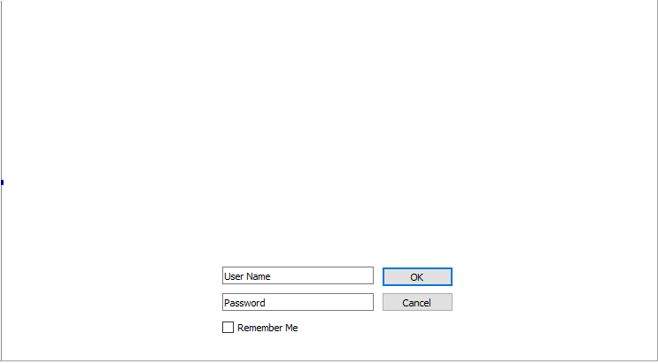

## appendix D: Major User ViewS

|  |  |  |  |
| --- | --- | --- | --- |
| **Data** | **Access Type** | **Administrators** | **Student** |
| **Administrators** | **Maintain** | **x** |  |
| **Query** | **x** | **x** |
| **Report** | **x** |  |
| **Join/Gen** | **x** |  |
| **Aggregate** | **x** |  |
| **Students** | **Maintain** | **x** |  |
| **Query** | **x** | **x** |
| **Report** | **x** |  |
| **Join/Gen** | **x** |  |
| **Aggregate** | **x** |  |
| **Courses** | **Maintain** | **x** |  |
| **Query** | **x** | **x** |
| **Report** | **x** | **x** |
| **Join/Gen** | **x** |  |
| **Aggregate** | **x** |  |
| **Grades** | **Maintain** | **x** |  |
| **Query** | **x** | **x** |
| **Report** | **x** | **x** |
| **Join/Gen** | **x** |  |
| **Aggregate** | **x** |  |

## appendix e: Use Cases

TBD

## appendix F: Diagrams

### UML Diagram

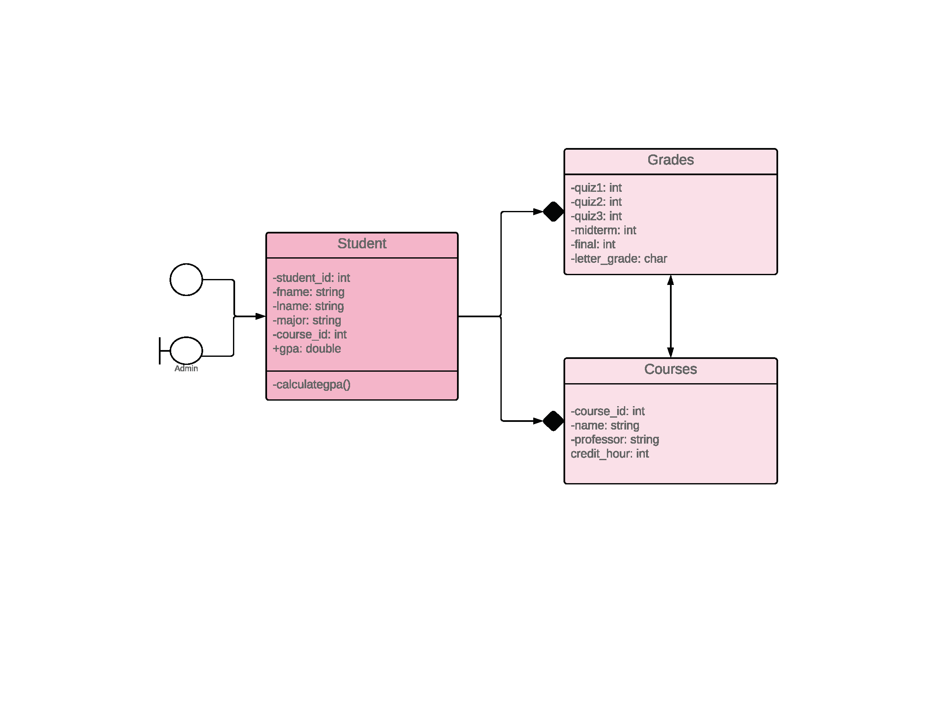

### E/R Diagram



administrators



teacher_id INT(11)



fname VARCHAR(30)



lname VARCHAR(30)



courses



course_id INT(11)



name VARCHAR(30)



teacher_id INT(11)



grades

student_id INT(11)

course_id INT(11)



quiz1 INT(11)



quiz2 INT(11)



quiz3 INT(11)



midterm INT(11)



final INT(11)



students



student_id INT(11)



fname VARCHAR(30)



lname VARCHAR(30)



major VARCHAR(30)



course_id INT(11)

### Detail Class Diagram

[TBC]

## appendix g: Meeting Minutes

[TBD]